Fun Days Holiday Playscheme Easter trip planner 2024
Monday 1st  April 2024 | Tuesday 2nd  April 2024 | Wednesday 3rd  April 2024 | Thursday 4th  April 2024 | Friday 5th  April 2024
Closed   | Spring face painting and art challenge day   | Holland Park adventure playground  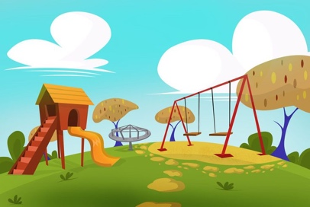 | Climbing wall for children 7+  City Bouldering  Cost: £18  Soft play for children 6 and under    Cost: £8.50 | Bluey is at Kew so are you!  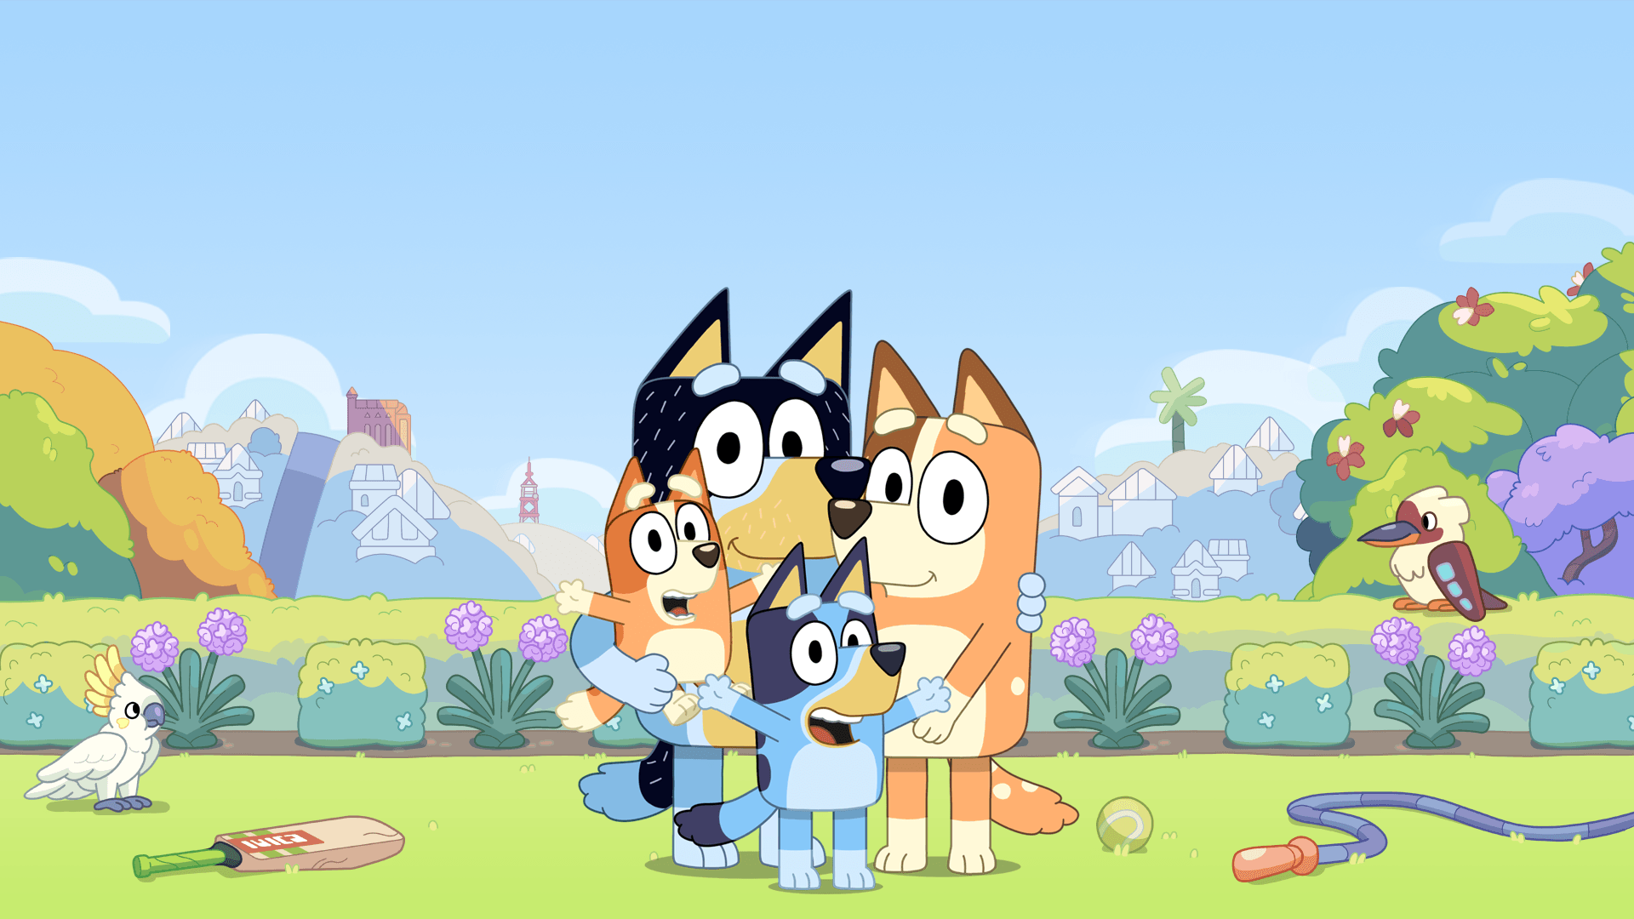  Cost: £5
Monday 8th  April 2024 | Tuesday 9th  April 2024 | Wednesday 10th  April 2024 | Thursday 11th  April 2024 | Friday 12th  April 2024
T-shirt art design    Are you going to tie dye or freehand paint your design? | Nature Treasure Hunt    I spy some sheep…….!  Prizes to be won! | Hobbledown Farm    Cost: £21 | Crystal palace Dino Park  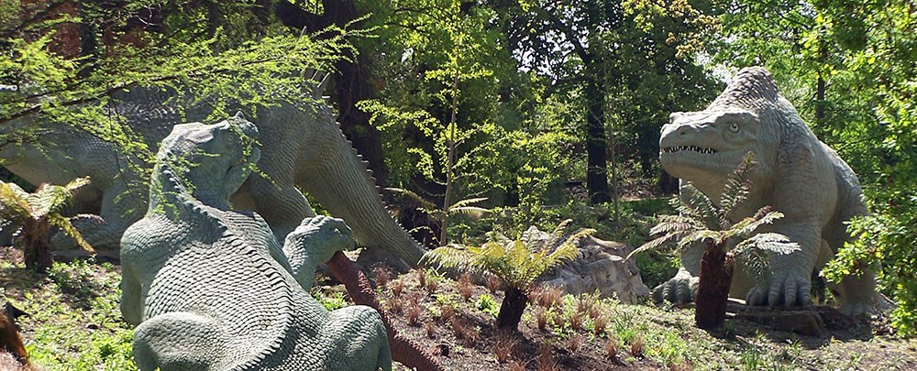 | Jungle Rumble Golf    Cost:£9
We will try to keep to our planned trips but sometimes things change, and we may not be in control of events, such as the weather. We hope you will be understanding of this, and we will try to arrange an alternative that is just as exciting.

